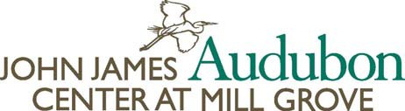

Be Inspired,
Become A Member
Mill Grove inspired John James Audubon to change the way Americans look at birds and na- ture. Now, the John James Audubon Center at Mill Grove (JJAC), along with our partners the Valley Forge Audubon Chap- ter, invites you and your
family to celebrate Audubon’s legacy of art, science and conservation throughout the year.
Become a member and take full advantage of the JJAC’s fun, educational and family-oriented resources, including more than 9 miles of walking trails, one of America’s largest collections of Audubon works, art and nature

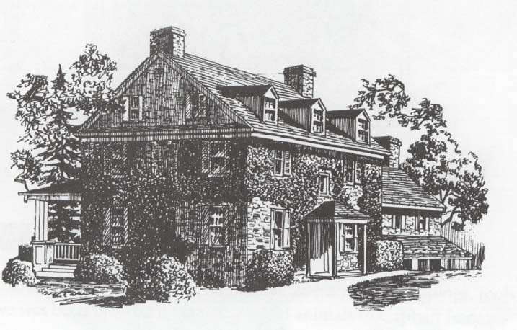
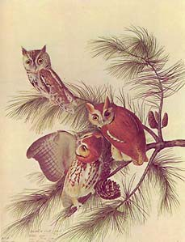
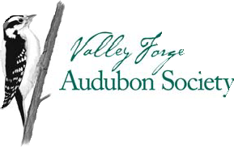
education classes, birding work- shops and other great programs.
By joining the JJAC, you’ll also automatically become a member of the National Audubon Society and its local chapter, the Valley Forge Audubon Society.
Membership not only gives you and your family great year-round activities, but it also protects and preserves one of this community’s great national treasures.

John James Audubon Center At Mill Grove
1201 Pawlings Road
Audubon, PA 19403
BENEFITS OF M EMBERSHIP

One year unlimited free admission to the John James Audubon Center at Mill Grove
- Free admission to family programs
- Free bird walks, lectures and other events sponsored by Valley Forge Audubon Society
- 10% discount at the Historic House Gift Shop
- Discounts for on-site classes
- Our members only e-newsletter
- One year of Audubon Magazine

Support our new efforts

Help support the construction of our new museum and visitor center, raptor building, bathrooms, and more. It is an exciting time at our center and we need your help!
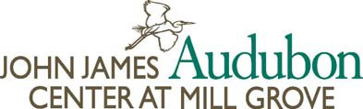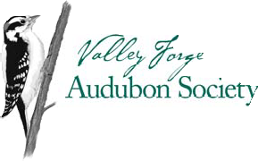
Become a Member Today
MEMBERSHIP LEVELS
APPLICATION FORM
All members receive a 10% discount at the gift shop, free bird walks, lectures and other events hosted by VFAS, dis- counted admission to special programs at Mill Grove, our e-newsletter, and a special one-year membership to the National Audubon Society. Admission benefits to the John James Audubon Center are based on membership-level:

Individual, $40 annually, $35 senior
Unlimited admission to the John James Audubon Center for 1 adult
Friends, $55 annually, $50 senior
Unlimited admission to the John James Audubon Center for 2 adults, plus 4 free passes for friends
Family, $55 annually, $50 senior
Unlimited admission to the John James Audubon Center for 2 adults and 4 children
Supporter, $100 annually
Unlimited admission to the John James Audubon Center for 2 adults and 4 children, plus 6 free Guest passes

Name:
Mailing Address:
City: State: | ZIP:
Home Phone: E-Mail Address:
Select Membership Level (see above):
Membership Cost: $ + Optional Contribution to Mill Grove $ | = Total $
Payment Method (Circle): Cash at Gift Shop Check Credit Card | (Visa or MasterCard)
Credit Card Information: Account # Expires: CVV code:
Signature for Credit Card Charges:
Check should be made payable to : Audubon
Included in your membership are 6 issues of AUDUBON magazine. Your gift is tax deductible except for $7.50 (which is allocated to AUDUBON magazine). AUDUBON is published 6 times a year. Please allow 4 to 6 weeks for the arrival of your first issue.
L.S. – Official Use Only:
Paid –
Scan –
E.A. –
S.F. –
Letter –

BRING OR MAIL FORM TO:
John James Audubon Center at Mill Grove 1201 Pawlings Road
Audubon PA 19403

