Pollution is something that is harmful or poisonous to a habitat, like trash or oil from cars. Choose one type of pollution and write, or draw, what might happen if that pollution got into the Blue Jay’s habitat in the box below:

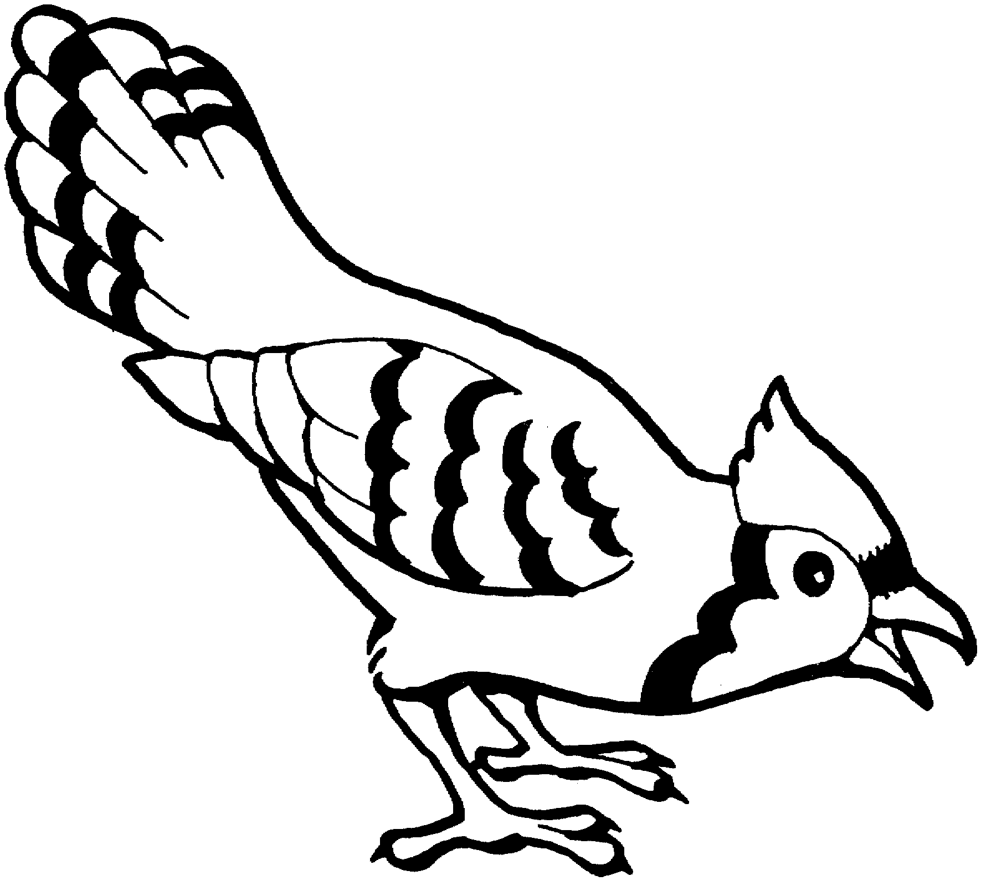

How would the pollution affect the 4 things (Food, Water, Shelter, & Space) that the Blue Jay needs? ____________________________________________________________________________________________________________________.

